**Homework 5: Host Auto-configuration and Day in Life of a UDP Application Message**

Exercise 1: **Host Behavior on “Link Up”**

Given the network topology at the end of this document, answer the following questions.

Suppose Host A is booting up for the first time on the network shown. Assume all caches on host A are empty.

1. What are four minimal pieces of routing and addressing configuration information Host A needs to be configured with to support sending user application messages?

-Host IP Address

-Ip address of first hop router

-Subnet mask

-DNS Server IP

1. How does a host like Host A typically acquire this information? Explain.

DNS: hostname-> IP

ARP: IP->MAC

DHCP: Config Info

Exercise 2: **Host Behavior on sending Application Message**

Suppose host A has booted up successfully and has acquired the minimum essential network configuration on the active network interface. A user has started an application on host A, which is to send a UDP Packet to an application on Server 1 at the host name server1.xyz.com. Assume all relevant caches are empty.

1. Describe all steps Host A must take (at all layers of the protocol stack) prior to sending the application message to Server 1. Include the addresses used in all protocol headers in the resulting packet in your answer.

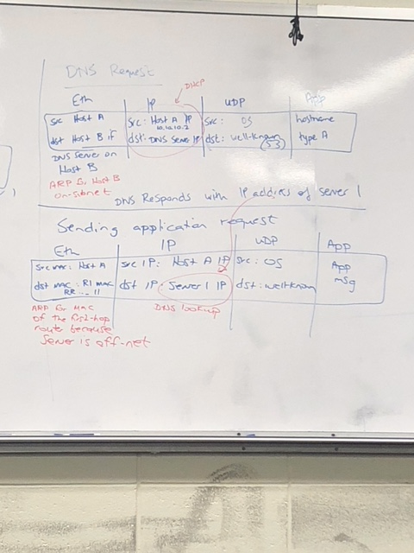

1. When the application message is received at the link layer interface on Server1, what steps does the network stack on the host take to deliver the message to the application process on Server1?

Verifies contents of header and make sure its not corrupt

Strip header

Passes it u to next higher layer

